HEALTH SAVINGS ACCOUNT

Under §223(a) of the Internal Revenue Code

CUSTODIAL AGREEMENT

AND DISCLOSURE STATEMENT

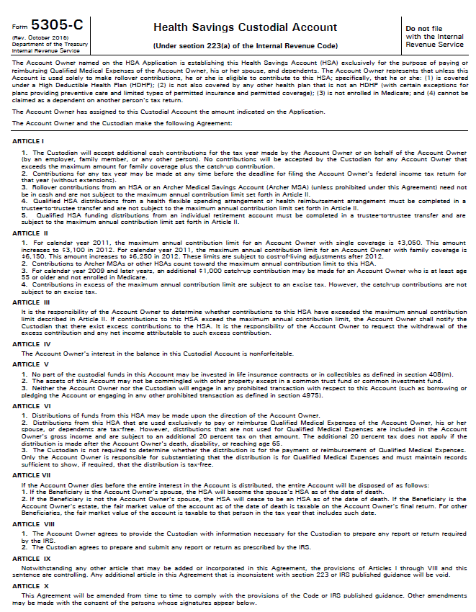
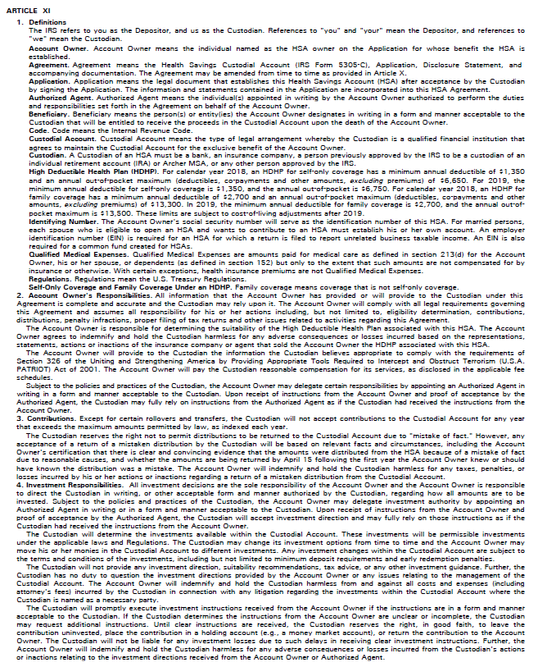
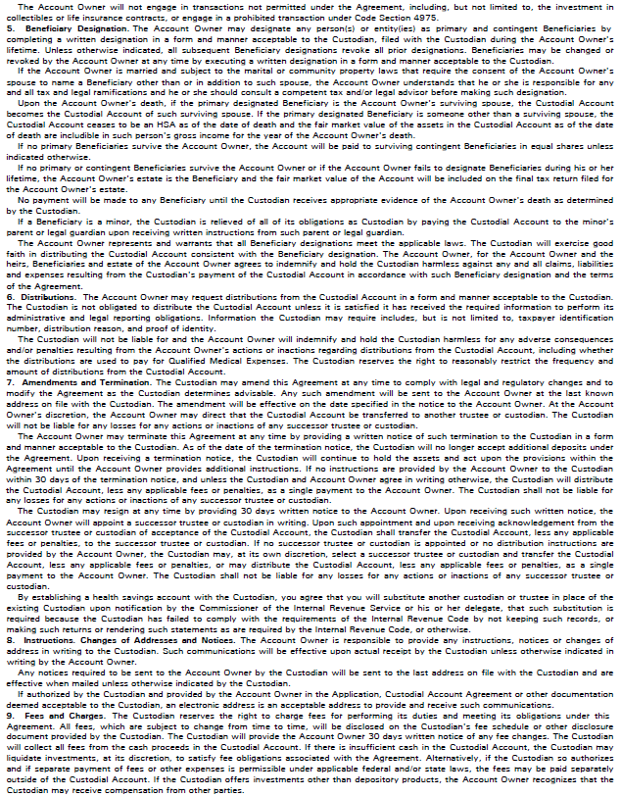

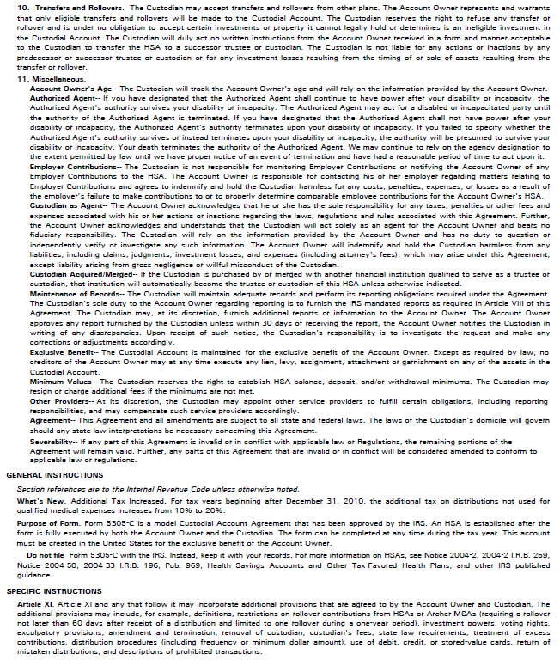

HSA DISCLOSURE STATEMENT

GENERAL REQUIREMENTS OF AN HSA

- Contributions must be made in cash, except for a rollover or transfer contribution from another HSA or Archer MSA and the Custodian accepts non-cash rollover or transfer contributions.
- For years prior to 2007, the annual regular contributions may not exceed the lesser of 100% of the annual deductible permitted under the Account Beneficiary’s High Deductible Health Plan for such year or a specified dollar limit, subject to the monthly contribution limit explained later.
- For years beginning in 2007, the annual regular contributions may not exceed the specified dollar limit depending upon the HDHP’s coverage (self-only or family), as adjusted for COLAs. These limits are explained later.
- Regular annual contributions for any taxable year may be deposited at any time during that taxable year and up to the due date for the filing of the Federal income tax return for that taxable year, no extensions. This generally means April 15th of the following year.
- The Custodian of an HSA must be a bank, insurance company or a person who is approved to act in such a capacity by the Secretary of the Treasury.
- No portion of the HSA funds may be invested in life insurance contracts.
- The interest in the HSA is nonforfeitable at all times.
- The assets in the HSA may not be commingled with other property except in a common trust fund or common investment fund.
- HSAs may not be invested in collectibles (as described in Section 408(m) of the Internal Revenue Code.) A collectible is defined as any work of art, rug or antique, metal or gem, stamp or coin, alcoholic beverage, or any other tangible personal property specified by the IRS. However, if the Custodian permits, specially minted US Gold and Silver bullion, coins and certain state-issued coins are permissible HSA investments.
- The assets of the HSA remain tax-exempt while the funds are in the Account.

WHO IS ELIGIBLE TO ESTABLISH AN HSA?

Regular contributions can be made to an HSA for any taxable year if the individual is an "Eligible Individual". The maximum contribution will be based on the number of months the individual is covered under a qualifying high deductible health plan (HDHP) and meets the definition of an eligible individual. The Account Beneficiary is responsible for determining whether he or she is an Eligible Individual, whether the health plan is an HDHP and the amount of the annual HSA contributions. The HSA custodian or trustee may, but is not required to, require proof or certification that the Account Beneficiary is an eligible individual, including that the individual is covered by a health plan that meets all of the requirements of an HDHP.

DEFINITIONS

Account Beneficiary

The Account Beneficiary is the individual on whose behalf the HSA is established and maintained. The Account Beneficiary must be an “eligible individual” in order to make HSA contributions.

Archer MSA

An Archer MSA is a Medical Savings Account described in section 220 of the Internal Revenue Code.

Designated Beneficiary

The person or persons named by the Account Beneficiary that will become entitled to the HSA balance upon the Account Beneficiary’s death.

Employer

Employers include the individual’s employer, the spouse’s employer, a self-employed individual, or the spouse of a self-employed individual. Employers that are members of a controlled group under Section 414 are considered a single employer for purposes of these rules.

Eligible Individual

The term "Eligible Individual" means, with respect to any month, any individual who:
(a) is covered under a high deductible health plan (HDHP) as of the first day of such month;
(b) is not also covered under any other health plan that is not a high deductible health plan while being covered by the high deductible health plan;
- is not enrolled in Medicare; and
- cannot be claimed as a dependent on another person’s income tax return.

The rule that requires that the employee not be covered under any other health plan does not include:
(a) coverage for any benefit provided by "permitted insurance" (See below for definition); and
(b) coverage (whether through insurance or otherwise) for accidents, disability, dental care, vision care, or long-term care.

High Deductible Health Plan (HDHP)

In the case of self-only coverage, the High Deductible Health Plan's annual deductible cannot be less than $1,000, adjusted for COLAs (for 2007 this amount is $1,100 and remains the same for 2008.). In the case of any other coverage (family coverage), the annual deductible cannot be less than $2,000, adjusted for COLAs (for 2007 this amount is $2,200 and remains the same for 2008).After 2008, the health plan’s deductible cannot be less than:
Self-only Coverage Family Coverage
2011 $1,200 $2,400
2012 $1,200 $2,400

The sum of the annual deductible and the other annual out-of-pocket expenses required to be paid under the plan (other than for premiums) for covered benefits may not exceed $5,000, adjusted for COLAs, for self-only coverage (for 2007 this amount is $5,500 and for 2008 it is $5,600), and $10,000, adjusted for COLAs, for family coverage (for 2007 this amount is $11,000 and for 2008 it is $11,200).After 2008, the maximum out-of-pocket cannot exceed:

Self-only Coverage Family Coverage
2011 $5,950 $11,900
2012 $6,050 $12,100

In the case of family coverage, a plan is an HDHP only if, under the terms of the plan and without regard to which family member or members incur expenses, no amounts are payable from the HDHP until the family has incurred annual covered medical expenses in excess of the minimum annual deductible. A plan does not fail to be an HDHP merely because it does not have a deductible (or has a small deductible) for certain preventive care (see below). Except for certain preventive care, a plan may not provide benefits for any year until the deductible for that year is met.

A High Deductible Health Plan shall not include a plan where substantially all of the coverage is for accidents, disability, dental care, vision care, or long-term care. Also a high deductible health plan shall not fail to be treated as an HDHP merely because the individual has coverage for any benefit provided by “permitted insurance” (see below).

Generally, an HDHP cannot provide any benefits for any year until the deductible for that year is satisfied.

Permitted Insurance

Permitted insurance is insurance under which substantially all of the coverage provided relates to liabilities incurred under workers’ compensation laws, tort liabilities, liabilities relating to ownership or use of property (e.g., automobile insurance), insurance for a specified disease or illness, and insurance that pays a fixed amount per day (or other period) of hospitalization.

Preventive Care Safe Harbor

IRS Notice 2004-23 provides a “safe harbor” for preventive care benefits allowed to be provided by a HDHP without satisfying the minimum deductible requirements. An HDHP may provide preventive care benefits without a deductible or with a deductible below the minimum annual deductible. Preventive care includes, but is not limited to, the following:

- Periodic health evaluations, including tests and diagnostic procedures ordered in connection with routine examinations, such as annual physicals.
- Routine prenatal and well-child care.
- Child and adult immunizations.
- Tobacco cessation programs.
- Obesity weight-loss programs.
- Screening services that are more fully described in the Appendix of Notice 2004-23

However, preventive care does not generally include any service or benefit intended to treat an existing illness, injury, or condition. Also, the determination of whether health care that is required by State law to be provided by an HDHP without regard to a deductible is “preventive” for purposes of the exception for preventive care under section 223(c)(2)(C) will be based on the standards set forth in Notice 2004-23 and other IRS guidance, rather than on how that care is characterized by State law.

Transitional Relief for Coverage Under HDHP and Separate Plan for Drug Benefits

IRS Revenue Ruling 2004-38 provides that if an individual is covered by both an HDHP that does not cover prescription drugs and by a separate prescription drug plan (or rider) that provides benefits before the minimum annual deductible of the HDHP has been satisfied, such individual is not eligible to establish an HSA and cannot make contributions to an HSA. The result is the same if the prescription drug benefit is provided as a benefit under a health plan (and not separately) or as a benefit for the individual under the spouse’s plan.

If a separate prescription drug plan (or rider) does not provide benefits until the minimum annual deductible of the HDHP has been satisfied, or the drug plan is part of an HDHP and subject to the minimum annual deductible, the individual is an eligible individual for purposes of establishing and making contributions to an HSA.

Because of the short period between the enactment of HSAs and its effective date, many employers and health insurance providers have been unable to modify the benefits provided under their existing health plans to conform to the requirements of an HDHP. Consequently, the IRS provides transitional relief to this rule in Revenue Procedure 2004-22. For months before January 1, 2006, an individual who would otherwise be an “eligible individual”, but is covered by a prescription drug benefit before the minimum annual deductible under the HDHP is satisfied, will continue to be an “eligible individual” and may make contributions to an HSA based on the annual deductible of the HDHP. This transitional relief expires on January 1, 2006.

Special Rules for Network Plans

In the case of a plan using a network of providers, special rules apply. A network plan is a plan that generally provides more favorable benefits for services provided by its network of providers than for services provided outside of the network. In the case of a plan using a network of providers, the plan does not fail to be an HDHP solely because the out-of-pocket expense limits for services provided outside of the network exceeds the maximum annual out-of-pocket expense limits allowed for an HDHP.

Qualified Medical Expenses

Qualified medical expenses include amounts paid with respect to the Account Beneficiary, the Account Beneficiary's spouse, and the Account Beneficiary's dependents, for medical care defined under section 213(d) and such amounts are not compensated for by insurance or otherwise.

To be “qualified medical expenses”, such expenses must be incurred only after the HSA has been established. However, IRS Notice 2004-25 provides a transitional rule for calendar year 2004 only. Under this transitional rule, eligible individuals who establish an HSA on or before April 15, 2005, may pay or reimburse on a tax-free basis an otherwise qualified medical expense if the qualified medical expense was incurred on or after the later of: (1) January 1, 2004, or (2) the first day of the first month that the individual became an eligible individual.

Generally, qualified medical expenses shall not include payment for insurance. Exceptions to this rule include any expense for coverage under:
(a) a health plan during any period of continuation coverage required under Federal law (COBRA);
(b) a qualified long-term care insurance contract (as defined in section 7702B(b) IRC); or
- a health plan during a period in which the individual is receiving unemployment compensation under any Federal or State law.

For individuals over age 65, premiums for the following health insurance may also be paid from the HSA:
- Medicare Part A
- Medicare Part B
- Medicare HMO
- Employee’s share of employer-sponsored health insurance
- Employer-sponsored retiree health insurance

However, premiums for Medigap policies are not qualified medical expenses.

Medical Care

Amounts for medical care that can be paid from an HSA include:

(a) the diagnosis, cure, mitigation, treatment, or prevention of disease, or for the purpose of affecting any structure or function of the body;
(b) for transportation primarily for and essential to medical care referred to above; or
(c) Amounts paid for certain lodging while away from home primarily for and essential to medical care, if such medical care is provided by a physician in a licensed hospital or medical care facility and there is no significant element of personal pleasure, recreation, or vacation in the travel away from home. The amount is limited to $50 per night per individual.

The term medical care does not include cosmetic surgery.

Compensation

Compensation shall not include amounts paid to an HSA, if it is reasonable to believe that such contributions can be excludable from income under Section 106(b).

Dependent

Dependent includes any of the following individuals who receive over half of their support for the calendar year from the taxpayer and is not being claimed as a dependent on another taxpayer’s return:

(a) Son or daughter, or a descendent of either;
(b) Stepson or stepdaughter;
(c) Brother, sister, stepbrother, or stepsister;
(d) Father or mother, or ancestor of either;
(e) Stepfather or stepmother;
(f) Son or daughter of a brother or sister;
(g) Brother or sister of the father or mother;
(h) Son-in-law, daughter-in-law, father-in-law, mother-in-law, brother-in-law, or sister-in-law; or
(i) An individual (other than an individual who at any time during the year was the taxpayer's spouse) who, for the taxable year of the taxpayer, has as his/her principal place of residence, the home of the taxpayer and is a member of the taxpayer's household.

The terms brothers and sisters include half-blood relatives. A child shall include a legally adopted child, a child who is placed in the taxpayer's home by an authorized placement agency for legal adoption, a foster child.

A dependent does not include an individual who is not a citizen of the US or of a country contiguous to the US. This does not include a child who is legally adopted by a US taxpayer.

CONTRIBUTIONS

Source of Regular Contributions

Cash contributions can either be made by an eligible individual, by any other person on behalf of an eligible individual, or by the employer of an employee who is an eligible individual. Unlike Archer MSAs, contributions to an HSA can be made by any of the above during the same year. Contributions made by another person are treated as if made by the Account Beneficiary. Regular HSA contributions are contributions other than rollover contributions or transfers from another HSA or Archer MSA, a mistake of fact reimbursement, or a one-time transfer from an FSA or HRA that are treated as a rollover contribution explained later. HSA contributions must be reduced by aggregate contributions to an Archer MSA. The same annual contribution limit applies regardless of whether the contributions are made by the individual, the individual’s employer or another person. If an individual has more than one HSA, the aggregate annual contributions to all of the individual’s HSAs are subject to the limit. After an individual has enrolled in Medicare, further contributions, including catch-up contributions, are no longer allowed. The monthly limit for such individual beginning the first month such individual is enrolled in Medicare shall be zero.

Contribution limits for 2004 through 2006

The maximum annual cash contribution is the sum of the limits determined separately for each month that the Account Beneficiary is an eligible individual. The maximum monthly contribution is the lesser of 100% of the annual deductible under the qualifying HDHP, or the maximum dollar limit divided by twelve.

HSA Contribution Limits beginning for 2007

Beginning for contributions made for 2007 and thereafter, an eligible individual’s annual HSA contribution limit is the specified maximum dollar limit, regardless of the health plan’s deductible amount. This provision permits eligible individuals to make higher HSA contributions when the health plan’s deductible amount is lower than the specified dollar limits.

Maximum Dollar Limit

Self-only Coverage Family Coverage

For 2004, $2,250 For 2004, $4,500
For 2005, $2,650 For 2005, $5,250
For 2006, $2,700 For 2006, $5,450
For 2007, $2,850 For 2007, $5,650
For 2008, $2,900 For 2008, $5,800
For 2009, $3,000 For 2009, $5,950
For 2010, $3,050 For 2010, $6,150
For 2011, $3,050 For 2011, $6,150
For 2012, $3,100 For 2012, $6,250

These dollar limits are adjusted for cost-of-living increases, rounded to the nearest increment of $50.

Partial Year Coverage under Qualifying HDHP

Prior to 2007, an eligible individual’s annual contribution limit was based upon the number of months during the year that the individual was actually covered under a qualifying high deductible health plan (HDHP). For example, if the individual began HDHP coverage on July 1st and the HDHP’s deductible amount was $2,000, the individual’s contribution limit for that year was $1,000 ($2,000/12 X 6 = $1,000). However, the HDHP’s deductible amount was not prorated. Consequently, the eligible individual still had to reach the HDHP’s $2,000 deductible before the health plan would pay any benefits.

Beginning for contributions made for 2007 and thereafter, if an eligible individual is covered under the HDHP during the last month of the year, the individual is eligible to make the full HSA contribution, depending upon the type of coverage under the HDHP (self-only or family). This provision, therefore, “deems” that the individual was covered under the HDHP for the entire year and thus permits the individual to make the full contribution regardless of the actual number of months he was covered under the HDHP.

For example, an individual becomes enrolled under his company’s HDHP with self-only coverage in December 2007. His 2007 HSA contribution limit is $2,850 even though he was covered under the HDHP for only one month during 2007.

However, in order to use this rule, the individual must continue coverage under the HDHP during the “testing period”. Otherwise, the amount contributed in excess of the amount that could have been contributed under the monthly-limitation rule is subject to tax, plus an additional tax equal to 10%. This tax applies for the year when the individual ceases to be eligible to make HSA contributions, except due to death or becoming disabled. The testing period begins the last month of the taxable year and ends on the last day of the 12th month following such month.

Prorating Still Applies in Some Cases

Prorating the contribution limit in accordance with the monthly-limitation rule still applies if the eligible individual does not remain covered under the HDHP for the entire year. For example, an eligible individual is covered under a qualifying HDHP with self-only coverage from January through June of 2007. This individual’s contribution limit for 2007 is $1,425 ($2,850/12 X 6 = $1,425).

Catch-up Contributions

For the Account Beneficiary (and spouse who is covered under the HDHP) who reaches age 55 before the end of a taxable year, an additional cash contribution may be made each year as follows:

2004: $500
2005: $600
2006: $700
2007: $800
2008: $900
2009 and thereafter: $1,000 (not subject to cost-of-living increases).

Catch-up contributions are also computed on a monthly basis. After an individual has enrolled in Medicare, further contributions, including catch-up contributions, are no longer allowed.

Annual HSA contributions must be made in cash (except as noted below) and may be made by an eligible individual, any other person on behalf of an eligible individual, or the employer of an eligible individual during any given year. Rollover and/or transfer contributions may be made in cash or in kind.

Qualified HSA Funding Distribution

Beginning for contributions made for 2007 and thereafter, a special one-time, tax-free transfer from an IRA to an HSA is permitted. This one-time transfer counts toward the eligible individual’s HSA contribution limit for the year of the transfer.

Prior to 2007, if an IRA owner wanted to use the money in an IRA to make an annual HSA contribution, the distribution from the IRA was taxable and subject to the 10% additional tax if the individual was under the age of 59½. Prior law did not provide for a tax-free transfer from an IRA to an HSA.

Beginning for annual HSA contributions made for 2007 or thereafter, an HSA-eligible individual may make an irrevocable once-in-a-lifetime, tax-free “Qualified HSA Funding Distribution” from an IRA to an HSA, subject however to strict requirements. The amount of the HSA funding distribution must be made in the form of a trustee-to-trustee transfer from the IRA to the HSA. The amount of the transfer cannot exceed the maximum HSA contribution limit for the year that the amount is transferred. Consequently, this one-time transfer from an IRA to an HSA counts toward the individual’s total HSA contribution limit for the year depending upon the type of coverage under the HDHP (self-only or family).

However, a special rule applies in the year of the initial transfer. If the individual has self-only coverage under the HDHP and makes a transfer under this rule from an IRA to an HSA, and then changes to family coverage under the HDHP in that same year, an additional transfer can be made to bring the individual up to the amount of the family coverage contribution limit, but must do so in the same year. Also, the IRA cannot be a SEP or SIMPLE.

This one-time transfer is different from the one-time transfer from an FSA or HRA discussed later. Whereas the FSA or HRA transfer does not count against the individual’s HSA contribution limit for the year, a transfer from the individual’s IRA does count toward the HSA contribution limit. Also, the amount transferred cannot be deducted as an HSA contribution because the amount transferred is not a taxable distribution from the IRA. Moreover, unlike the FSA or HRA transfers, there is no deadline to make this one-time transfer from an IRA to an HSA. The amount transferred from the IRA to the HSA will be treated as coming first from the taxable portion of the IRA. Thus, this will be an exception to the normal pro-rata taxation rules applicable to traditional IRAs.

However, if the individual ceases to be an HSA-eligible individual during the “testing period”, the amount transferred is taxable and subject to the 10% additional tax if the individual is under the age of 59½ unless the individual dies or becomes disabled. For this purpose, the testing period begins with the month in which the qualified HSA funding distribution is contributed to an HSA and ends on the last day of the 12th month following such month.

Other General Rules

HSA contributions may be made regardless of whether the eligible individual has compensation. The HSA contribution limit is reduced by any contributions for the year to an Archer MSA. If the Account Beneficiary has more than one HSA, the aggregate of all contributions are subject to the contribution limit.

The taxpayer reports all contributions and distributions by submitting Form 8889 with his or her income tax return. If a penalty is due because of an excess contribution, Form 5329 must be completed in addition to Form 8889.

Married Individuals

Jointly-owned HSAs are not permitted. An HSA is established by or on behalf of an eligible individual.

In the case of eligible individuals who are married to each other, if either spouse has family coverage, both are treated as having family coverage. If each spouse has family coverage under a separate health plan, both spouses are treated as covered under the plan with the lowest deductible. The total contribution limit for the spouses is divided equally between the spouses, unless they agree on a different division. The family coverage limit is reduced by any contribution to an Archer MSA. However, both spouses may make the catch-up contributions for individuals age 55 or over without exceeding the family coverage limit. There is no formal method specified how a married couple agrees on a different division of the total contribution amount. If only one spouse is an eligible individual, only that spouse may contribute to an HSA.

Timing of HSA Contributions

HSA contributions must be made for a calendar year no later than the due date for filing the taxpayer's Federal income tax return for such calendar year, not including extensions. Contributions for the taxable year can be made in one or more payments. The maximum contribution may be made on the first day of the year.

Deduction Permitted If Contribution made by Eligible Individual or Another Individual

If an eligible individual makes a contribution to an HSA, or another individual makes a contribution on behalf of an eligible individual, an “above-the-line” deduction is permitted by the eligible individual for the taxable year equal to an amount which is the aggregate amount paid in cash during such taxable year to an HSA, subject to the contribution limit. However, if the HSA eligible individual makes the one-time, tax-free transfer from an IRA to fund the HSA for the year, no deduction is permitted with respect to the amount transferred. Contributions made by an employer within the contribution limits of the HSA are not deductible by the eligible individual, but rather treated as employer-provided coverage for medical expenses and are excluded from income. HSA contributions are deductible whether or not the eligible individual itemized deductions. An individual who may be claimed as a dependent on another person’s tax return is not an eligible individual and may not deduct contributions to an HSA. HSA rules are applied without regard to community property laws.

Employer Contributions to HSA

Employer contributions to an HSA are not included in the compensation of the employee. The employer treats the HSA contributions as employer-provided coverage for medical expenses under an accident or health plan. The employer must report the amount of the HSA contribution on the employee's W-2 Form in accordance with IRS instructions for that form. Employer contributions to an HSA are not subject to withholding from wages for income tax purposes or subject to FICA, FUTA or the Railroad Retirement Tax Act. Contributions to an employee’s HSA through a cafeteria plan are treated as employer contributions. In this case, the employee cannot deduct employer HSA contributions on his or her Federal income tax return as HSA contributions or as medical expense deductions under section 213.

If the employer chooses to make HSA contributions, then the employer is required to make comparable HSA contributions for all participating employees (i.e., eligible employees with comparable coverage) during the same period. A comparable HSA employer contribution is (1) the same dollar amount or (2) the same percentage of the annual deductible under the high deductible health plan covering the employees divided into groups of "comparable coverage".

Comparable coverage can vary between self-only coverage, family coverage and part-time employees. A part-time employee means an employee who customarily works less than 30 hours per week. The comparability rule does not apply to amounts rolled over from an employee’s HSA or Archer MSA, or to contributions made through a cafeteria plan.

If employer contributions do not comply with the comparability rule during a period, then the employer is subject to an excise tax equal to 35% of the aggregate amount contributed by the employer to HSAs for that period.

Employer Contributions to an Employee’s HSA Do Not Constitute an “ERISA” Plan

The Labor Department’s Employee Benefits Security Administration issued Field Assistance Bulletin No. 2004-01 that rules that HSAs generally will not constitute an employee welfare benefit plan for purposes of Title I of ERISA. As noted in the FAB, HSAs are personal health care savings vehicles rather than a form of group health insurance so long as the establishment of the HSA is completely voluntary on the part of the employee and the employer does not: (1) limit the ability of the eligible individual to move their funds to another HSA; (2) impose conditions on the utilization of HSA funds; (3) make or influence the investment decisions with respect to funds contributed to an HSA; (4) represent that the HSAs are an employee welfare benefit plan established or maintained by the employer; or (5) receive any payment or compensation in connection with the HSA.

EXCESS CONTRIBUTIONS

Generally an excess HSA contribution is any contribution made for a taxable year that exceeds the contribution limits, and such excess contribution is subject to a 6% excise tax on the principal amount of the excess each year until the excess is corrected. Excess HSA contributions are not deductible by the individual if made by or on behalf of the individual. Excess HSA contributions made by the individual’s employer are included in the gross income of the employee.

Withdrawing Excess By Tax Filing Due Date - This 6% excise tax may be avoided, if the excess amount plus the earnings attributable to the excess are distributed by the individual’s tax filing deadline including extensions for the year for which the excess contribution was made, and no deduction is taken for such excess amount. If the excess is corrected in this manner, the principal amount of the excess returned is not taxable, however, the earnings attributable to the excess are taxable in the year in which the distribution is received. Such earnings are also subject to the 10% additional tax (20% beginning in 2011), unless another exception applies.

Excess contributions made for one taxable year can be carried over to subsequent years, in order of time, subject to the subsequent year’s contribution limit. The 6% excise tax is applied each year on the uncorrected excess amount as of the end of each taxable year.

ROLLOVER HSAs

Rollover Contributions – Rollover contributions are permitted from another HSA or Archer MSA. A rollover from another HSA or Archer MSA is any amount received from one HSA or MSA and rolled over to an HSA. The entire amount received from the first HSA or MSA is not required to be rolled over. However, any amount not rolled over will be taxed at ordinary income tax rates for Federal income tax purposes, and may be subject to an additional 10% tax (20% beginning in 2011) if the distribution does not meet one of the exceptions.

The following special rules also apply to rollovers between HSAs, or from an Archer MSA to an HSA:

- The rollover must be completed no later than the 60th day after the day the distribution was received.
- A total distribution is not required from the distributing HSA or MSA in order to make a rollover contribution into another HSA.

If a rollover is made from an HSA or MSA to an HSA, another rollover cannot be made until 12 months has passed since the first rollover. If a second rollover is made before the 12-month period has expired, such subsequent rollover cannot be treated as a tax-free rollover, and thus will be considered a taxable distribution.

If an HSA is inherited by another person due to the death of the Account Beneficiary, no rollover is permitted unless the spouse of the decedent is the designated beneficiary.

Rollovers from any other type of account (such as IRAs, health reimbursement arrangements, or health flexible spending arrangements) to an HSA are not permitted.

One-Time Transfer from an FSA or HRA to an HSA

Unused amounts in a Health Flexible Spending Arrangement (FSA) are forfeited at the end of each year. Balances in Health Reimbursement Arrangements (HRAs) are amounts solely funded by the employer and employees do not contribute to the HRA.

Under the Tax Relief and Health Care Act of 2006, an HSA-eligible individual may make a one-time, tax-free transfer from an FSA or HRA to an HSA called a “qualified HSA distribution”. The amount transferred is limited to the lesser of (1) the balance in the FSA or HRA on September 21, 2006; or (2) the balance in the FSA or HRA on the date of the transfer. Also, this one-time transfer must be done on or before December 31, 2011.

The transferred amount is treated as a rollover contribution to the HSA and thus does not reduce the HSA-eligible individual’s HSA contribution limit for the year of the transfer. The amount transferred from the FSA or HRA to the HSA must be made directly by the employer to the trustee or custodian of the HSA. This provision applies only to existing FSAs or HRAs on September 21, 2006. An FSA or HRA established after September 21, 2006, would have had a balance of zero on September 21, 2006, consequently having zero eligible to make this one-time transfer contribution.

If the HSA-eligible individual makes this one-time transfer from an FSA or HRA to an HSA, but then ceases to be an HSA-eligible individual at any time during the “testing period”, the amount transferred will be taxed and subject to an additional 10% tax for the year the individual ceases to be HSA-eligible. This taxation does not apply if the individual dies or becomes disabled. For this purpose, the testing period begins with the month in which the qualified HSA distribution is transferred to the HSA and ends on the last day of the 12th month following such month. The amount transferred is treated as an employer contribution made to the employee’s HSA, and therefore is not deductible by the employee.

TRANSFERS

A direct transfer of all or a portion of funds is permitted from this HSA to another HSA or from another HSA or MSA to this HSA. Transfers do not constitute a distribution since the funds are not treated as received. The monies are transferred directly to the new custodian or trustee. Direct transfers are not subject to the 60-day period or the 12-month rule described above under “Rollover HSAs”.

If all or a portion of an HSA is transferred to a former spouse's HSA under a divorce decree (or under a written instrument incident to divorce) or separation instrument, the HSA Account Beneficiary will not be deemed to have made a taxable distribution, but merely a transfer. The portion so transferred will be treated at the time of the transfer as the HSA of the Account Beneficiary’s spouse or former spouse.

A direct transfer of all or a portion of funds is permitted from this HSA to another HSA or from another HSA or MSA to this HSA. Transfers do not constitute a distribution since the funds are not treated as received. The monies are transferred directly to the new trustee or custodian. Direct transfers are not subject to the 60-day period or the 12-month rule described above under “Rollover HSAs”.

If all or a portion of an HSA is transferred to a former spouse's HSA under a divorce decree (or under a written instrument incident to divorce) or separation instrument, the HSA Account Beneficiary will not be deemed to have made a taxable distribution, but merely a transfer. The portion so transferred will be treated at the time of the transfer as the HSA of the Account Beneficiary’s spouse or former spouse.

Special rules apply to a one-time transfer from an FSA or HRA to an HSA. Such transfer is treated as a rollover as described under “Rollover HSAs.”

Special rules apply to a one-time transfer from an IRA to an HSA. Such transfer is treated as a regular contribution for the year of the transfer as described earlier under “Contributions”.

DISTRIBUTIONS

Distributions – In General

Distributions from an HSA are permitted at any time. The custodian or trustee may, in its own discretion, permit payments from this HSA through any of the following:

1. Payments made directly to the Account Beneficiary;
2. Payments made directly to the medical service provider;
3. Check writing capabilities; or
4. Debit, credit or stored-value cards.

The Account Beneficiary may request a distribution from the HSA as qualified medical expenses are incurred, or may periodically reimburse himself or herself from the HSA for qualified medical expenses that have been incurred and paid by the individual.

Taxation of Distributions

Any amounts distributed from an HSA for qualified medical expenses of the Account Beneficiary, his or her spouse, or dependents are not included in the Account Beneficiary’s gross income for the year and are not subject to any additional income tax. Amounts in an HSA can be used for qualified medical expenses and will be excludable from gross income even if the individual is not currently eligible for contributions to the HSA.

Any amounts distributed from an HSA that are not used to exclusively pay for qualified medical expenses of the Account Beneficiary, his or her spouse, or dependents are included in the gross income of the Account Beneficiary. Also, such distributions will be subject to an additional 10% income tax (20% beginning in 2011), unless another exception applies.

Exceptions to the additional income tax include:

(a) Distributions due to the Account Beneficiary becoming disabled (defined under section 72(m)(7) IRC)
(b) Distributions made to the designated beneficiary(ies) upon the death of the Account Beneficiary.
(c) Distributions made to a taxpayer after such individual becomes eligible for Medicare. (The age specified in section 1811 of the Social Security Act. This is currently age 65.)
(d) Distributions from an HSA that are subsequently rolled over to another HSA within 60 days after the day of receipt of the distribution and meet the other requirements for a Rollover HSA.

Distributions are not required to begin at age 70½.

The Account Beneficiary is solely responsible for determining the taxability or non-taxability of any distribution from an HSA. IRS Form 8889 is filed by the taxpayer to report contributions to an HSA, distributions from an HSA, or an acquisition of interest in an HSA because of the death of the account beneficiary.

Death of the Account Beneficiary

Upon the Account Beneficiary’s death, any balance remaining in the HSA becomes the property of the designated beneficiary named in the HSA instrument as the designated beneficiary of the account.

If the Account Beneficiary designated his or her spouse as the designated beneficiary, the surviving spouse shall be automatically treated as the Account Beneficiary of the HSA after the original Account Beneficiary's death. This means that when the Account Beneficiary dies, if the surviving spouse is the designated beneficiary, then such account is assumed automatically by the surviving spouse as his or her own HSA and will then be treated as the Account Beneficiary for whom the HSA is maintained. The surviving spouse is subject to income tax only to the extent distributions from the HSA are not used for qualified medical expenses.

If any other person is the designated beneficiary, then the HSA ceases to be an HSA on the date of the Account Beneficiary’s death. If the designated beneficiary is a non-spouse, the fair market value of the HSA on the date of death is includible in such non-spouse beneficiary’s gross income for such taxable year. If the Account Beneficiary's estate is the designated beneficiary, then the fair market value of the HSA on the decedent’s date of death is includible in the decedent's gross income on the last tax return filed on behalf of the decedent. For such a person (except the decedent’s estate), the includable amount is reduced by any payments from the HSA made for the decedent’s qualified medical expenses, if paid within one year after death.

An appropriate deduction is allowed under section 691(c) to any person (other than the decedent or the decedent’s spouse) with respect to amounts included in gross income by such person.

Other Distributions

Distributions from an HSA that are not used to pay qualified medical expenses are included in gross income for the year and may also be subject to an additional 10% income tax (20% beginning in 2011), unless the distribution is received due to death; disability; attaining age 65; a qualifying rollover distribution; or the timely withdrawal of the principal amount of an excess contribution.

Mistake of Fact Distributions

Distributions (or reimbursements) from an HSA may be returned if there was reasonable cause due to a mistake-of-fact for the Account Beneficiary to believe the expenses incurred were qualified medical expenses. If there is ‘clear and convincing evidence’, the Account Beneficiary may repay the distribution to the HSA no later than April 15 of the year following the year the Account Beneficiary knew (or should have known) that the expense was not a qualified medical expense. Amounts repaid under this circumstance are not included in gross income and are not subject to the additional income tax. Repayment amounts will also not be treated as new contributions or as a rollover.

Coordination of Medical Expense Deduction

For purposes of determining the amount of the medical expense deduction on the taxpayer’s Federal income tax return under section 213, any payment or distribution from an HSA for qualified medical expenses shall not be treated as an expense paid for medical care. Tax-free HSA distributions used for qualified medical expenses reduce the taxpayer’s medical expense deduction for Federal income tax purposes.

PROHIBITED TRANSACTIONS

If the Account Beneficiary or designated beneficiary engage in a prohibited transaction (as defined under Section 4975 of the Internal Revenue Code) with the HSA, it will lose its tax exemption and the value of the account is included in gross income for that taxable year. If any portion of an HSA is pledged as collateral for a loan, the amount so pledged will be treated as a distribution and will be included in gross income for that year.

PENALTIES

If a distribution is made for non-medical reasons from an HSA, an additional 10% income tax (20% beginning in 2011) will apply on the taxable amount of the distribution, unless another exception applies discussed earlier.

If an excess contribution is made to an HSA and it is not corrected on a timely basis, an excise tax of 6% is imposed on the excess amount. This tax will apply each year to any part or all of the excess that remains in the account.

IRS Form 5329 must be filed with the Internal Revenue Service for any year an additional tax is due.

FEDERAL ESTATE AND GIFT TAXES

Generally, there is no specific exclusion for HSAs under the Federal estate tax rules. Therefore, in the event of death, the HSA balance will be includible in the Account Beneficiary’s gross estate for Federal estate tax purposes. However, if the surviving spouse is the beneficiary of the HSA, the amount in the HSA may qualify for the marital deduction available under Section 2056 of the Internal Revenue Code. A transfer of property for Federal gift tax purposes does not include an amount that a beneficiary receives from an HSA plan.

